|  |
| --- |
| Computer Programming |
| Course Code: CSC 113 |
| **Semester Project Report** |

**Name:** Saif Sultan **Enrollment Number**: 01-134232-164

1. **Project title:** **Delight Tours**
2. **Group Members:**

|  |  |  |
| --- | --- | --- |
| **Sr. No** | **Full Name** | **Enrollment Number** |
| **1** | Arshia Jamil | 01-134232-044 |
| **2** | Saif Sultan | 01-134232-164 |
| **3** | Imranuddin Siraji | 01-134232-242 |

1. **Project Description:**

**Main Window:**

**Description:**

This page is the point from where our program starts. Click on the button will take us to the next screen from the use interaction begins.

**Source Code:**

**mainwindow.h:**

#ifndef MAINWINDOW_H

#define MAINWINDOW_H

#include <QMainWindow>

#include"profile.h"

QT_BEGIN_NAMESPACE

namespace Ui { class MainWindow; }

QT_END_NAMESPACE

class MainWindow : public QMainWindow

{

Q_OBJECT

public:

MainWindow(QWidget *parent = nullptr);

~MainWindow();

private slots:

void on_welcome_clicked();

private:

Ui::MainWindow *ui;

};

#endif // MAINWINDOW_H

**mainwindow.cpp:**

#include "mainwindow.h"

#include "ui_mainwindow.h"

MainWindow::MainWindow(QWidget *parent)

: QMainWindow(parent)

, ui(new Ui::MainWindow)

{

ui->setupUi(this);

}

MainWindow::~MainWindow()

{

delete ui;

}

void MainWindow::on_welcome_clicked()

{

hide();

profile prof;

prof.setModal(true);

prof.exec();

}

**Screenshot:**



**Profile Page:**

**Description:**

This page acts as a user profile form, collecting and validating personal information for hotel booking. Users enter their name, age, phone number, CNIC (presumably a national ID), and number of travelling members. Clear buttons are provided for easy correction.

Upon clicking "Submit", the code checks if required fields are filled and verifies the entered data adheres to specific formats for age, phone number, and CNIC. Error messages guide users if any input is incorrect. If everything is valid, the user's name gets stored in a global data structure for later use, and the current form disappears. Finally, a new form for hotel selection pops up, presumably leading to the next step in the booking process.

Overall, this page serves as a data entry checkpoint before proceeding with hotel booking, ensuring accurate user information is captured and available for subsequent steps.

**Source Code:**

**profile.h:**

#ifndef PROFILE_H

#define PROFILE_H

#include <QDialog>

#include "hotelchoice.h"

namespace Ui {

class profile;

}

class profile : public QDialog

{

Q_OBJECT

public:

explicit profile(QWidget *parent = nullptr);

~profile();

private slots:

void on_subbtn_clicked();

private:

Ui::profile *ui;

// Add pointers to your Line Edit widgets

};

#endif // PROFILE_H

**profile.cpp:**

#include "profile.h"

#include "ui_profile.h"

#include <QMessageBox>

#include <QRegularExpression>

#include "userdata.h"

#include "bill.h"

#include <QSettings>

profile::profile(QWidget *parent) :

QDialog(parent),

ui(new Ui::profile)

{

ui->setupUi(this);

ui->name->setClearButtonEnabled(true);

ui->age->setClearButtonEnabled(true);

ui->phone->setClearButtonEnabled(true);

ui->cnic->setClearButtonEnabled(true);

ui->members->setClearButtonEnabled(true);

}

profile::~profile() {

QObject::~QObject();

delete ui;

}

void profile::on_subbtn_clicked() {

// Get Input From User

QString name = ui->name->text();

QString age = ui->age->text();

QString members = ui->members->text();

QString cnic = ui->cnic->text();

QString phone = ui->phone->text();

// Define regular expressions for input validation

QRegularExpression ageRegex("^\\d+$"); // Match digits only for age

QRegularExpression phoneRegex("^\\+92\\d{3}-\\d{7}$"); // Match specific phone format

QRegularExpression cnicRegex("^\\d{5}-\\d{7}-\\d{1}$"); // Match specific CNIC format

// Check for required fields

if (name.isEmpty() || members.isEmpty()) {

QMessageBox::warning(this, "Error", "Please fill in all required fields!");

return;

}

// Validate age format

if (!ageRegex.match(age).hasMatch()) {

QMessageBox::warning(this, "Error", "Invalid age format! Please enter digits only.");

return;

}

// Validate phone number format

if (!phoneRegex.match(phone).hasMatch()) {

QMessageBox::warning(this, "Error", "Invalid phone number format! Please follow the required format.");

return;

}

// Validate CNIC format

if (!cnicRegex.match(cnic).hasMatch()) {

QMessageBox::warning(this, "Error", "Invalid CNIC format! Please follow the required format.");

return;

}

// Store the name in a global data structure

UserData::instance().setName(name);

// Hide the current form and display the hotel choice form

hide();

hotelchoice hc;

hc.setModal(true);

hc.exec();

}

**Screenshots:**

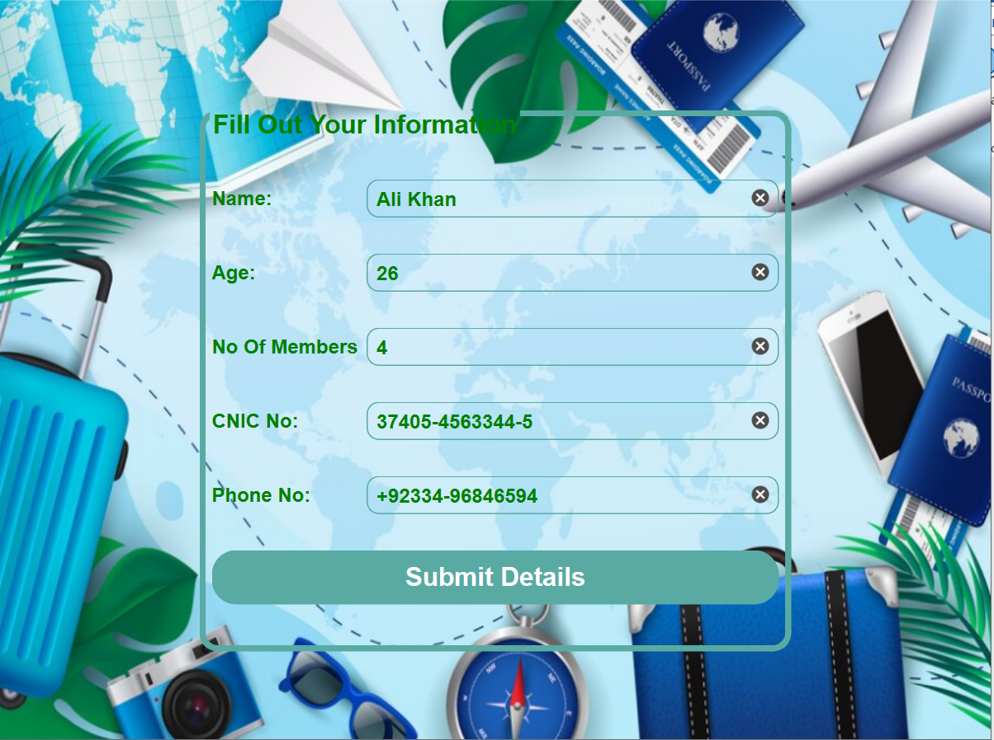

**User enter his details, if any is missing or incorrect format is used an error is displayed.**

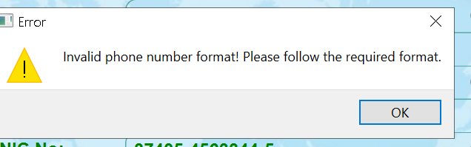

**This is how the error message looks like.**

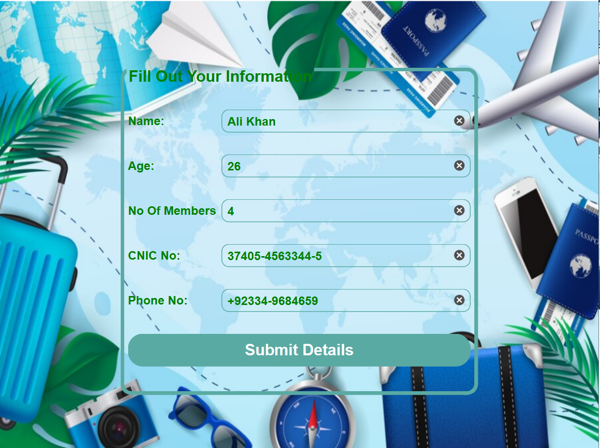

**If he enter the correct format, user is directed to next page.**

**Hotel Choice Page:**

This page acts as a hotel selection hub, presenting users with three hotel options: Hotel Rosemary, Hotel Royal Den, and Hotel Platium. Clicking on any hotel hides the current page and opens a dedicated page showcasing details and booking options for the chosen hotel. These detailed pages are launched as modal windows, requiring the user to engage with them before returning to the selection menu. Essentially, this page acts as a decision point, allowing users to navigate towards the specific hotel they're interested in for further exploration and potential booking.

**Source Code:**

**hotelchoice.h:**

#ifndef HOTELCHOICE_H

#define HOTELCHOICE_H

#include <QDialog>

#include"hotelrosemary.h"

namespace Ui {

class hotelchoice;

}

class hotelchoice : public QDialog

{

Q_OBJECT

public:

explicit hotelchoice(QWidget *parent = nullptr);

~hotelchoice();

private slots:

void on_hotel1_clicked();

void on_hotel2_clicked();

void on_pushButton_3_clicked();

signals:

void sendHotelCost(quint32 hotelCost);

private:

Ui::hotelchoice *ui;

};

#endif // HOTELCHOICE_H

**hotelchoice.cpp:**

#include "hotelchoice.h"

#include "ui_hotelchoice.h"

#include"hotelrosemary.h"

#include"hotelroyalden.h"

#include"guildtesero.h"

hotelchoice::hotelchoice(QWidget *parent) :

QDialog(parent),

ui(new Ui::hotelchoice)

{

ui->setupUi(this);

}

hotelchoice::~hotelchoice()

{

delete ui;

}

void hotelchoice::on_hotel1_clicked()

{

//hides courrent form and shows the hotel detailed page

hide();

hotelrosemary hr;

hr.setModal(true);

hr.exec();

}

void hotelchoice::on_hotel2_clicked()

{

//hides courrent form and shows the hotel detailed page

hide();

hotelroyalden rd;

rd.setModal(true);

rd.exec();

}

void hotelchoice::on_pushButton_3_clicked()

{

//hides courrent form and shows the hotel detailed page

hide();

guildtesero gt;

gt.setModal(true);

gt.exec();

}

**Screenshots:**

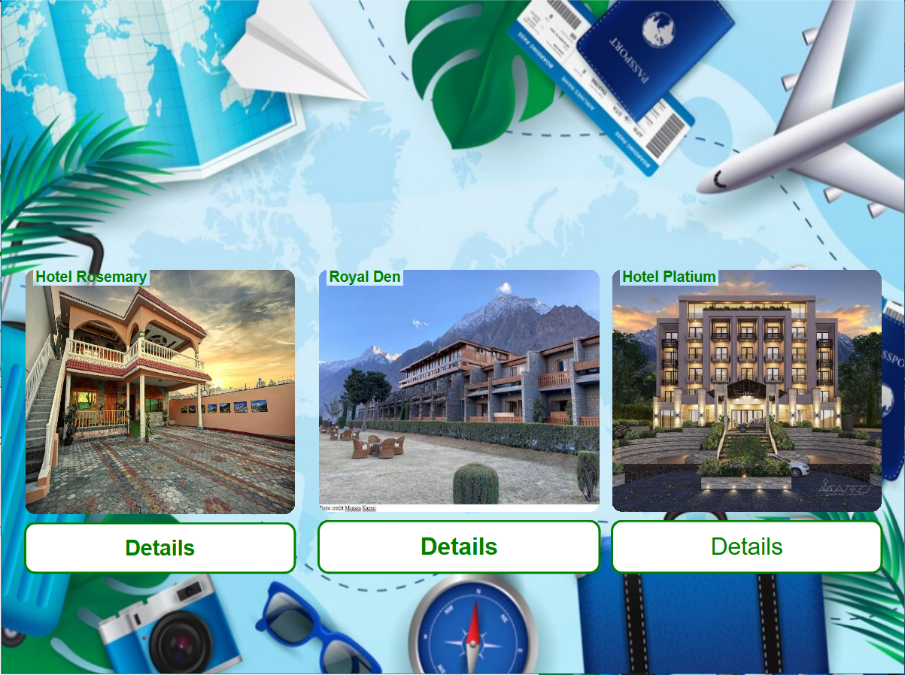

**User can select any one of the three hotels. User can also look at all options by going forward and back with the buttons.**

**Hotel Rosemary Page:**

This page lets you book a stay at Hotel Rosemary. Choose a room, enter your desired dates, and see if it's available. If it is, the page calculates the cost and lets you finalize the booking, updating a file with your details. It then whisks you off to a tour planning page to help you fill your stay with exciting activities. If your chosen dates are already booked, you'll be politely informed and can try another room or hotel. You can also head back to explore other hotel options at any time. Essentially, this page handles the booking process for Hotel Rosemary, leading you smoothly to planning your perfect stay if the room and dates work out.

**Source Code:**

**hotelrosemary.h:**

#ifndef HOTELROSEMARY_H

#define HOTELROSEMARY_H

#include <QDialog>

#include<QMessageBox>

#include<QFile>

#include<QTextStream>

namespace Ui {

class hotelrosemary;

}

class hotelrosemary : public QDialog

{

Q_OBJECT

public:

explicit hotelrosemary(QWidget *parent = nullptr);

~hotelrosemary();

private slots:

void on_bookbtn_clicked();

void on_backbtn_clicked();

private:

Ui::hotelrosemary *ui;

};

#endif // HOTELROSEMARY_H

**hotelrosemary.cpp:**

#include "hotelrosemary.h"

#include "ui_hotelrosemary.h"

#include "tourplan.h"

#include "hotelchoice.h"

#include <QDate>

#include"userdata.h"

#include"bill.h"

#include<QSettings>

hotelrosemary::hotelrosemary(QWidget *parent) :

QDialog(parent),

ui(new Ui::hotelrosemary)

{

ui->setupUi(this);

// Populate room numbers in the dropdown

for (int i = 101; i < 110; i++) {

ui->roomno->addItem(QString::number(i));

}

}

hotelrosemary::~hotelrosemary()

{

delete ui;

}

bool roomAvailable = true;

void hotelrosemary::on_bookbtn_clicked() {

//Gets input from user

QString roomNumber = ui->roomno->currentText();

QString checkInDate = ui->checkin->text();

QString checkOutDate = ui->checkout->text();

// Ensure the "available_rooms.txt" file exists

QFile check("available_rooms.txt");

if (!check.exists()) {

if (!check.open(QIODevice::WriteOnly | QIODevice::Text)) {

QMessageBox::warning(this, "Error", "Failed to create file.");

return;

}

check.close();

}

// Check room availability by reading the file

QFile file("available_rooms.txt");

if (file.open(QIODevice::ReadOnly | QIODevice::Text)) {

while (!file.atEnd()) {

QString line = file.readLine();

QStringList parts = line.split(',');

// Check if the room is already booked during the requested dates

if (parts[0] == roomNumber &&

((checkInDate > parts[1] && checkInDate < parts[2]) ||

(checkOutDate > parts[1] && checkOutDate < parts[2]))) {

roomAvailable = false;

break;

}

}

file.close();

} else {

QMessageBox::warning(this, "Error", "Failed to open file.");

return;

}

// Proceed with booking if the room is available

if (roomAvailable) {

// Calculate the number of days between check-in and check-out dates

QDate checkIn = QDate::fromString(checkInDate, "MM/dd/yyyy");

QDate checkOut = QDate::fromString(checkOutDate, "MM/dd/yyyy");

int days = qAbs(checkOut.daysTo(checkIn));

// Calculate the hotel cost

quint32 hotelcost = 12000 * days;

// Append the booking information to the "available_rooms.txt" file

if (file.open(QIODevice::Append | QIODevice::Text)) {

file.write(roomNumber.toUtf8() + "," + checkInDate.toUtf8() + "," + checkOutDate.toUtf8() + "\n");

file.flush();

file.close();

// Show confirmation message and proceed to tour plan

QMessageBox::information(this, "Congratulations", "Room " + roomNumber + " is booked for you from " + checkInDate + " to " + checkOutDate + ". Total cost: " + QString::number(hotelcost));

UserData::instance().setHotelCost(hotelcost);

//Hides Current form and shows next one

hide();

tourplan tp;

tp.setModal(true);

tp.exec();

} else {

QMessageBox::warning(this, "Error", "Failed to write to file.");

return;

}

} else {

// Inform the user if the room is unavailable

QMessageBox::information(this, "Room Availability", "Room " + roomNumber + " is already booked for those dates.");

}

}

// Handle back button click to return to the hotel choice form

void hotelrosemary::on_backbtn_clicked() {

hide();

hotelchoice hc;

hc.setModal(true);

hc.exec();

}

**Screenshots:**

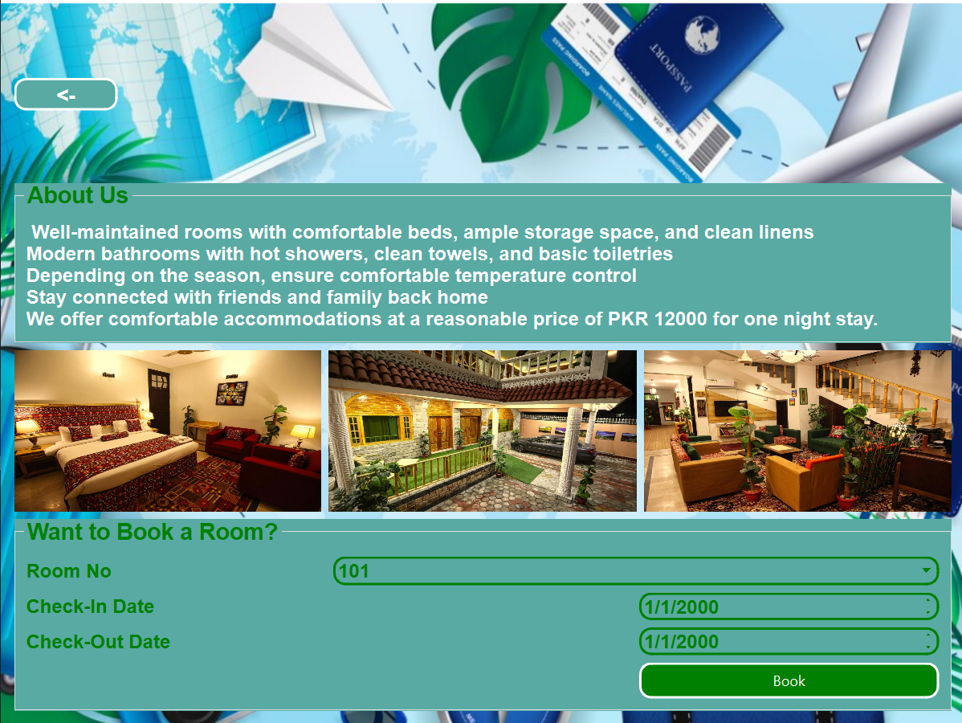

**User can select a room no of his choice, If the room is booked the user will get a message displayed that room is booked. If not then the room for that date will be booked for user.**

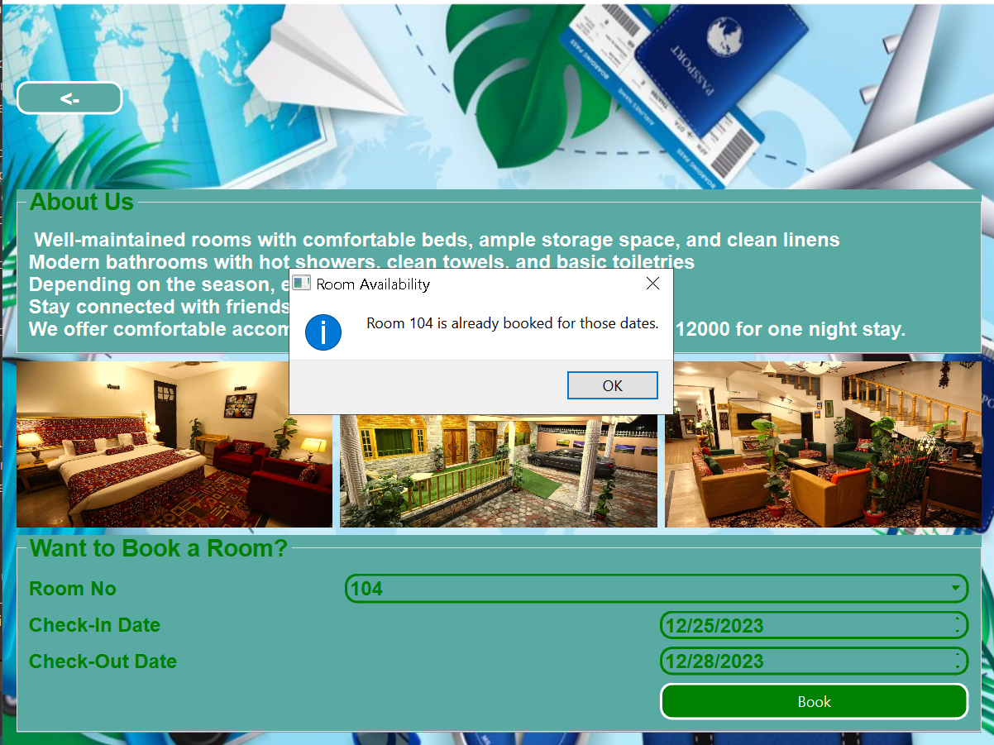

**Message showing that room is already booked.**

**Hotel Royal Den Page:**

Hotel Royal Den takes center stage here! Similar to its Rosemary counterpart, this page lets you reserve a room, choose your dates, and check availability. If a room is free for your stay, the page calculates the cost and lets you finalize the booking, updating a dedicated file with your details. You'll then be whisked away to plan exciting activities for your trip. But if your desired dates are already taken, don't worry! A friendly message will let you know, and you can either try another room or head back to explore other hotels. Just like Hotel Rosemary, this page handles all your booking needs for Hotel Royal Den, seamlessly guiding you towards a perfect stay if the room and dates fit the bill.

**Source Code:**

**hotelroyalden.h:**

#ifndef HOTELROYALDEN_H

#define HOTELROYALDEN_H

#include <QDialog>

#include<QMessageBox>

#include<QFile>

#include<QTextStream>

namespace Ui {

class hotelroyalden;

}

class hotelroyalden : public QDialog

{

Q_OBJECT

public:

explicit hotelroyalden(QWidget *parent = nullptr);

~hotelroyalden();

private slots:

void on_bookbtnroyal_clicked();

void on_backbtnroyal_clicked();

private:

Ui::hotelroyalden *ui;

int hotelcost;

};

#endif // HOTELROYALDEN_H

**hotelroyalden.cpp:**

#include "hotelroyalden.h"

#include "ui_hotelroyalden.h"

#include "tourplan.h"

#include "hotelchoice.h"

#include <QDate>

#include"userdata.h"

#include"bill.h"

#include<QSettings>

hotelroyalden::hotelroyalden(QWidget *parent) :

QDialog(parent),

ui(new Ui::hotelroyalden)

{

ui->setupUi(this);

hotelcost=0;

// Populate room numbers in the dropdown

for (int i = 235; i <= 250; i++) {

ui->royalroom->addItem(QString::number(i));

}

}

hotelroyalden::~hotelroyalden()

{

delete ui;

}

void hotelroyalden::on_bookbtnroyal_clicked() {

//Get Input from user

QString roomNumber = ui->royalroom->currentText();

QString checkInDate = ui->royaldate->text();

QString checkOutDate = ui->royaldate2->text();

// Ensure the "royalden.txt" file exists for storing booking information

QFile check("royalden.txt");

if (!check.exists()) {

if (!check.open(QIODevice::WriteOnly | QIODevice::Text)) {

QMessageBox::warning(this, "Error", "Failed to create file.");

return;

}

check.close();

}

// Check room availability by reading the file

QFile file("royalden.txt");

bool roomAvailable = true;

if (file.open(QIODevice::ReadOnly | QIODevice::Text)) {

while (!file.atEnd()) {

QString line = file.readLine();

QStringList parts = line.split(',');

// Check if the room is already booked during the requested dates

if (parts[0] == roomNumber &&

((checkInDate > parts[1] && checkInDate < parts[2]) ||

(checkOutDate > parts[1] && checkOutDate < parts[2]))) {

roomAvailable = false;

break;

}

}

file.close();

} else {

QMessageBox::warning(this, "Error", "Failed to open file.");

return;

}

// Proceed with booking if the room is available

if (roomAvailable) {

// Calculate the number of days between check-in and check-out dates

QDate checkIn = QDate::fromString(checkInDate, "MM/dd/yyyy");

QDate checkOut = QDate::fromString(checkOutDate, "MM/dd/yyyy");

int days = qAbs(checkOut.daysTo(checkIn));

// Calculate the hotel cost

int hotelcost = 26000 * days;

// Append the booking information to the "royalden.txt" file

if (file.open(QIODevice::Append | QIODevice::Text)) {

file.write(roomNumber.toUtf8() + "," + checkInDate.toUtf8() + "," + checkOutDate.toUtf8() + "\n");

file.flush();

file.close();

// Store the hotel cost in a global data structure

UserData::instance().setHotelCost(hotelcost);

// Show confirmation message and proceed to tour plan

QMessageBox::information(this, "Congratulations", "Room " + roomNumber + " is booked for you from " + checkInDate + " to " + checkOutDate + ". Total cost: " + QString::number(hotelcost));

//Hides Current form and shows next one

hide();

tourplan tp;

tp.setModal(true);

tp.exec();

} else {

QMessageBox::warning(this, "Error", "Failed to write to file.");

return;

}

} else {

// Inform the user if the room is unavailable

QMessageBox::information(this, "Room Availability", "Room " + roomNumber + " is already booked for those dates.");

}

}

// Handle back button click to return to the hotel choice form

void hotelroyalden::on_backbtnroyal_clicked() {

hide();

hotelchoice hc;

hc.setModal(true);

hc.exec();

}

**Screenshots:**

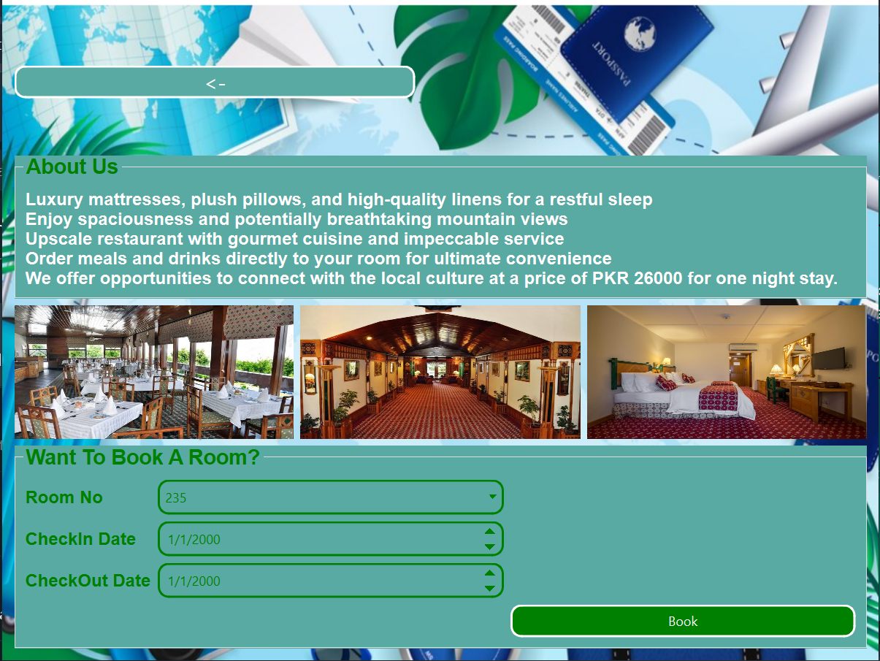

**User can select a room no of his choice, If the room is booked the user will get a message displayed that room is booked. If not then the room for that date will be booked for user.**

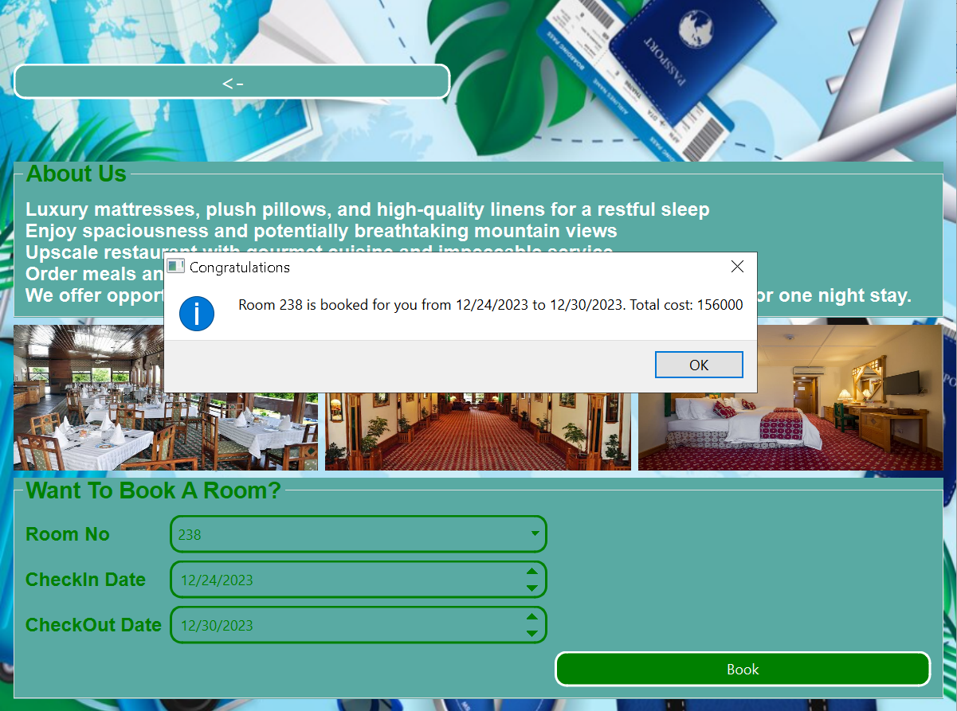

**Message showing that room is booked for the user.**

**Hotel Platium Page:**

This page focuses on booking accommodation at the Hotel Platium. It offers a familiar interface where you can select your desired room and dates. Behind the scenes, it diligently checks room availability by consulting a file called "guildtesero.txt". If your chosen room is free for your stay, the page calculates the cost (based on a daily rate of 65000, in Pakistani Rupees) and presents you with a confirmation message. It then whisks you away to plan exciting activities for your trip. However, if the room is unavailable for your selected dates, it gracefully informs you with a message, allowing you to either adjust your dates or explore other options. Like the pages for Hotel Rosemary and Hotel Royal Den, this page streamlines the booking process for Hotel Platium, leading you seamlessly towards planning your stay if the room and dates align.

**Source Code:**

**guildtesero.h:**

#ifndef GUILDTESERO_H

#define GUILDTESERO_H

#include <QDialog>

#include<QFile>

#include<QTextStream>

#include<QMessageBox>

#include"global.h"

namespace Ui {

class guildtesero;

}

class guildtesero : public QDialog

{

Q_OBJECT

public:

explicit guildtesero(QWidget *parent = nullptr);

~guildtesero();

private slots:

void on_gtbook_clicked();

void on_gtback_clicked();

private:

Ui::guildtesero *ui;

};

#endif // GUILDTESERO_H

**guildtesero.cpp:**

#include "guildtesero.h"

#include "ui_guildtesero.h"

#include "tourplan.h"

#include "hotelchoice.h"

#include"userdata.h"

#include"bill.h"

#include<QSettings>

guildtesero::guildtesero(QWidget *parent) :

QDialog(parent),

ui(new Ui::guildtesero)

{

ui->setupUi(this);

// Populate room numbers in the dropdown

for (int i = 20; i <= 60; i++) {

ui->gtrooms->addItem(QString::number(i));

}

}

guildtesero::~guildtesero()

{

delete ui;

}

void guildtesero::on_gtbook_clicked() {

//Get Input From User

QString roomNumberH3 = ui->gtrooms->currentText();

QString checkInDateH3 = ui->gtdate->text();

QString checkOutDateH3 = ui->gtdate2->text();

bool roomAvailable = true; // Flag to indicate room availability

// Ensure the "guildtesero.txt" file exists for storing booking information

QFile check("guildtesero.txt");

if (!check.exists()) {

if (!check.open(QIODevice::WriteOnly | QIODevice::Text)) {

QMessageBox::warning(this, "Error", "Failed to create file.");

return;

}

check.close();

}

// Check room availability by reading the file

QFile file("guildtesero.txt");

if (!file.open(QIODevice::ReadOnly | QIODevice::Text)) {

QMessageBox::warning(this, "Error", "Failed to open file.");

return;

}

// Iterate through file lines to check for existing bookings

while (!file.atEnd() && roomAvailable) {

QString line = file.readLine();

QStringList parts = line.split(',');

// If the requested room is already booked for the given dates, mark as unavailable

if (parts[0] == roomNumberH3 &&

((checkInDateH3 > parts[1] && checkInDateH3 < parts[2]) ||

(checkOutDateH3 > parts[1] && checkOutDateH3 < parts[2]))) {

roomAvailable = false;

break;

}

}

file.close();

// Proceed with booking if the room is available

if (roomAvailable) {

// Calculate the number of days between check-in and check-out dates

QDate checkIn = QDate::fromString(checkInDateH3, "MM/dd/yyyy");

QDate checkOut = QDate::fromString(checkOutDateH3, "MM/dd/yyyy");

int days = qAbs(checkOut.daysTo(checkIn));

// Calculate the hotel cost

quint32 hotelcost = 65000 * days;

// Append booking details to guildtesero.txt

if (file.open(QIODevice::Append | QIODevice::Text)) {

file.write(roomNumberH3.toUtf8() + "," + checkInDateH3.toUtf8() + "," + checkOutDateH3.toUtf8() + "\n");

file.flush();

file.close();

// Store the hotel cost in a global data structure

UserData::instance().setHotelCost(hotelcost);

// Display confirmation message and proceed to tour plan

QMessageBox::information(this, "Congratulations", "Room " + roomNumberH3 + " is booked for you from " + checkInDateH3 + " to " + checkOutDateH3 + ". Total cost: " + QString::number(hotelcost));

//Hides Current form and shows next one

hide();

tourplan tp;

tp.setModal(true);

tp.exec();

}

else {

QMessageBox::warning(this, "Error", "Failed to write to file.");

return;

}

}

else {

// Inform user about room unavailability

QMessageBox::information(this, "Room Availability", "Room " + roomNumberH3 + " is already booked for those dates.");

}

}

// Handle back button click to return to the hotel choice form

void guildtesero::on_gtback_clicked() {

hide();

hotelchoice hc;

hc.setModal(true);

hc.exec();

}

**Screenshots:**

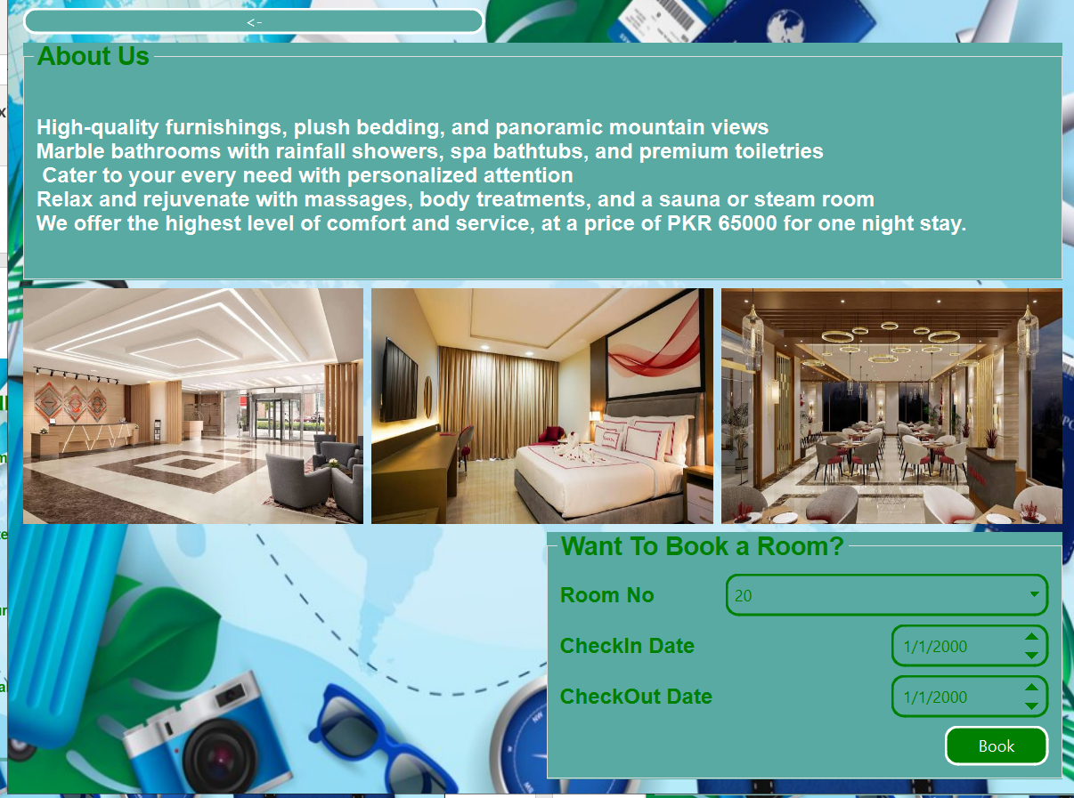

**User can select a room no of his choice, If the room is booked the user will get a message displayed that room is booked. If not then the room for that date will be booked for user.**

**Tour Plan Selection Page:**

This page serves as a gateway to planning exciting activities for your trip. It presents two distinct options to cater to different preferences:

Pre-Planned Packages: By clicking the "Pre-Planned Packages" button, you'll be guided to a page showcasing curated packages with detailed itineraries, perfect for those seeking a hassle-free and well-structured experience.

Custom Packages: If you crave a more personalized touch, the "Custom Packages" button will lead you to a page where you can craft your own unique adventure, tailoring it to your specific interests and desires.

This page acts as a crossroads, empowering you to choose your preferred path for crafting a memorable experience.

**Source Code:**

**tourplan.h:**

#ifndef TOURPLAN_H

#define TOURPLAN_H

#include <QDialog>

namespace Ui {

class tourplan;

}

class tourplan : public QDialog

{

Q_OBJECT

public:

explicit tourplan(QWidget *parent = nullptr);

~tourplan();

private slots:

void on_pppack_clicked();

void on_cuspack_clicked();

private:

Ui::tourplan *ui;

};

#endif // TOURPLAN_H

**tourplan.cpp:**

#include "tourplan.h"

#include "ui_tourplan.h"

#include"preplanned.h"

#include"customindoor.h"

tourplan::tourplan(QWidget *parent) :

QDialog(parent),

ui(new Ui::tourplan)

{

ui->setupUi(this);

}

tourplan::~tourplan()

{

delete ui;

}

void tourplan::on_pppack_clicked() {

// Hide the current tour plan window and opens the pre-planned packages

hide();

preplanned pp;

pp.setModal(true);

pp.exec();

}

void tourplan::on_cuspack_clicked() {

// Hide the current tour plan window and opens the custom

hide();

customindoor ci;

ci.setModal(true);

ci.exec();

}

**Screenshots:**

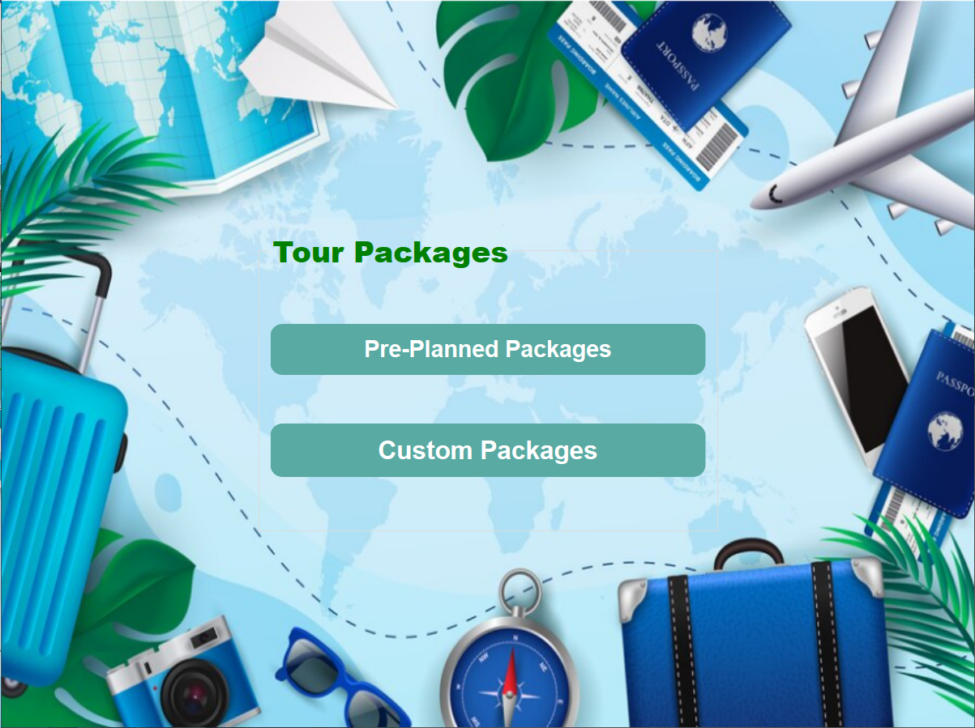

**User can select between Custom or Pre-planned packages.**

**Pre-Planned Tour Package Selection Page:**

Here's a description of the code in paragraph form:

This page unveils a variety of pre-planned tour packages, meticulously crafted to cater to diverse preferences and budgets. It acts as a central hub, presenting three distinct options for you to explore:

* Premium Packages: Designed for those seeking an exclusive and luxurious experience, these packages promise top-notch accommodations, exclusive activities, and unparalleled service.
* Normal Packages: Offering a balanced approach, these packages provide comfortable arrangements, a variety of popular attractions, and a good value for your money.
* Economy Packages: Ideal for budget-conscious travelers, these packages focus on affordability without compromising on quality, ensuring a fulfilling experience without breaking the bank.

To delve deeper into the specifics of each package, simply select your preferred category. If you wish to revisit other tour planning options, a convenient back button is available to guide you back to the previous page.

**Source Code:**

**preplanned.h:**

#ifndef PREPLANNED_H

#define PREPLANNED_H

#include <QDialog>

namespace Ui {

class preplanned;

}

class preplanned : public QDialog

{

Q_OBJECT

public:

explicit preplanned(QWidget *parent = nullptr);

~preplanned();

private slots:

void on_prembtn_clicked();

void on_normalbtn_clicked();

void on_ecobtn_clicked();

void on_pushButton_clicked();

private:

Ui::preplanned *ui;

};

#endif // PREPLANNED_H

**preplanned.h:**

#include "preplanned.h"

#include "ui_preplanned.h"

#include"premium.h"

#include"normal.h"

#include"economy.h"

#include"tourplan.h"

preplanned::preplanned(QWidget *parent) :

QDialog(parent),

ui(new Ui::preplanned)

{

ui->setupUi(this);

}

preplanned::~preplanned()

{

delete ui;

}

void preplanned::on_prembtn_clicked()

{

//Hides current form

hide();

//shows the next form

premium pre;

pre.setModal(true);

pre.exec();

}

void preplanned::on_normalbtn_clicked()

{

//Hides current form

hide();

//shows the next form

normal nor;

nor.setModal(true);

nor.exec();

}

void preplanned::on_ecobtn_clicked()

{

//Hides current form

hide();

//shows the next form

economy ec;

ec.setModal(true);

ec.exec();

}

void preplanned::on_pushButton_clicked()

{

//Goes back to previous form

hide();

tourplan tp;

tp.setModal(true);

tp.exec();

}

**Screenshots:**

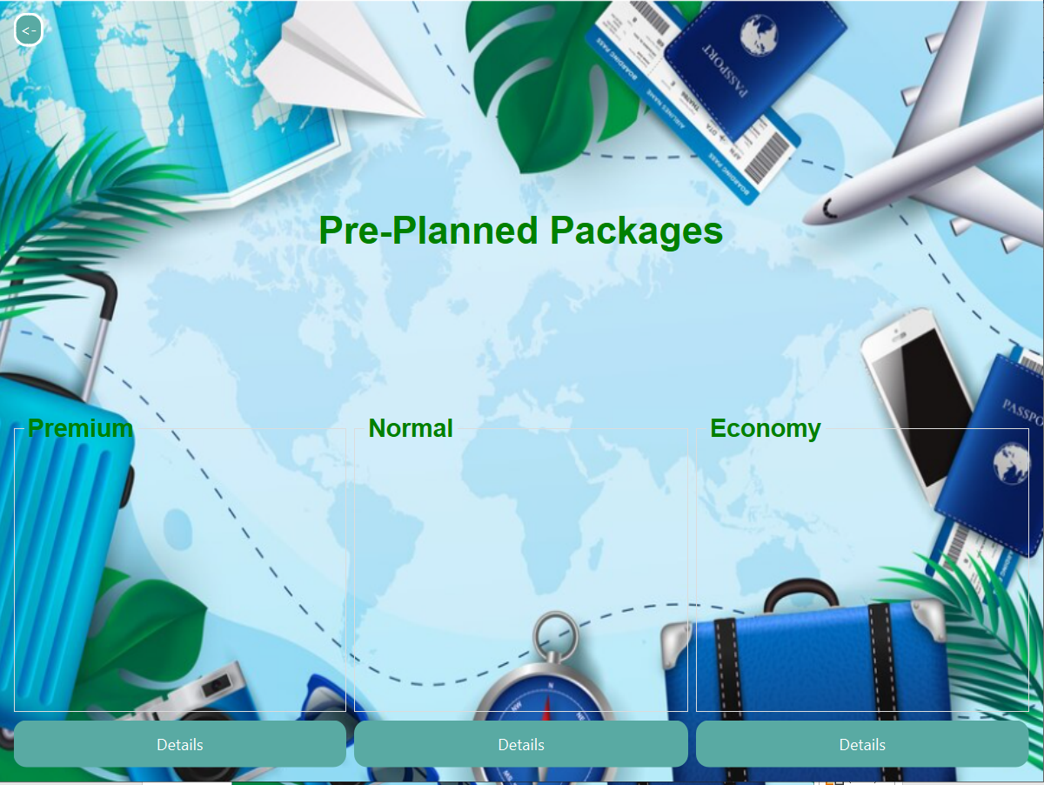

**User can look into details of all packages and can also go back to see the custom package.**

**Premium Tour Package Selection Page:**

This page presents the details of the premium tour package, enticing you with its luxurious offerings. If you're captivated by the allure of this premium adventure, you can confidently confirm your booking with a simple click. Upon confirmation, a message will reassure you that your upscale experience is now secured. The page then seamlessly whisks you away to the billing stage, where you'll finalize the financial arrangements for your grand escapade. However, if you have a change of heart or wish to explore other options, a back button is available to guide you back to the pre-planned tour package overview.

**Source Code:**

**premium.h:**

#ifndef PREMIUM_H

#define PREMIUM_H

#include <QDialog>

#include<QMessageBox>

namespace Ui {

class premium;

}

class premium : public QDialog

{

Q_OBJECT

public:

explicit premium(QWidget *parent = nullptr);

~premium();

private slots:

void on_backbtn_clicked();

void on_cofirmbtn_clicked();

private:

Ui::premium *ui;

};

#endif // PREMIUM_H

**premium.cpp:**

#include "premium.h"

#include "ui_premium.h"

#include"preplanned.h"

#include"userdata.h"

#include"bill.h"

premium::premium(QWidget *parent) :

QDialog(parent),

ui(new Ui::premium)

{

ui->setupUi(this);

}

premium::~premium()

{

delete ui;

}

void premium::on_backbtn_clicked()

{

// Hide's current form

hide();

//Shows Previous form

preplanned back;

back.setModal(true);

back.exec();

}

void premium::on_cofirmbtn_clicked()

{

// Prompt the user for booking confirmation

int result = QMessageBox::question(this, "Confirmation", "Do you want to book the premium Package for 32000 PKR?", QMessageBox::Yes | QMessageBox::No);

if (result == QMessageBox::Yes) { // If user confirms booking

// Perform booking actions

quint32 tourPackageCost = 32000;

// Display confirmation message

QMessageBox::information(this, "Congratulations", "Your Premium Tour has been booked");

// Store booking details in global data structure

UserData::instance().setPackagetype("Pre-planned");

UserData::instance().setTourCost(tourPackageCost);

// Hides Current form

hide();

//Displays the next form

bill bil;

bil.setModal(true);

bil.exec();

} else { // If user does not confirm booking

// Handle actions for canceled booking (placeholder)

}

}

**Screenshots:**

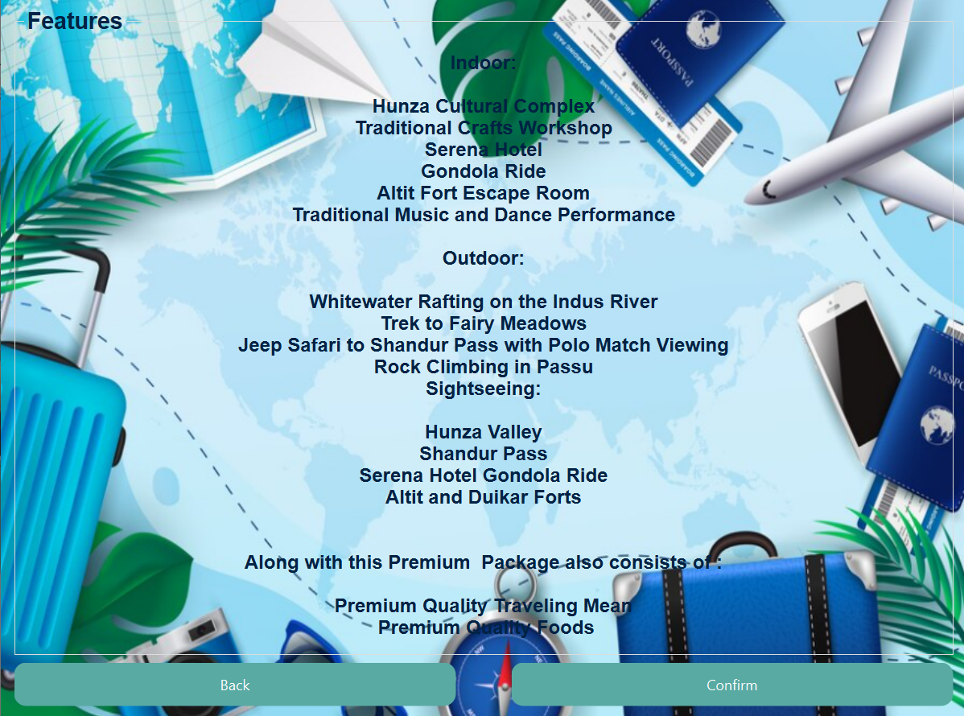

**User can book himself this package or can see between the other pages.**

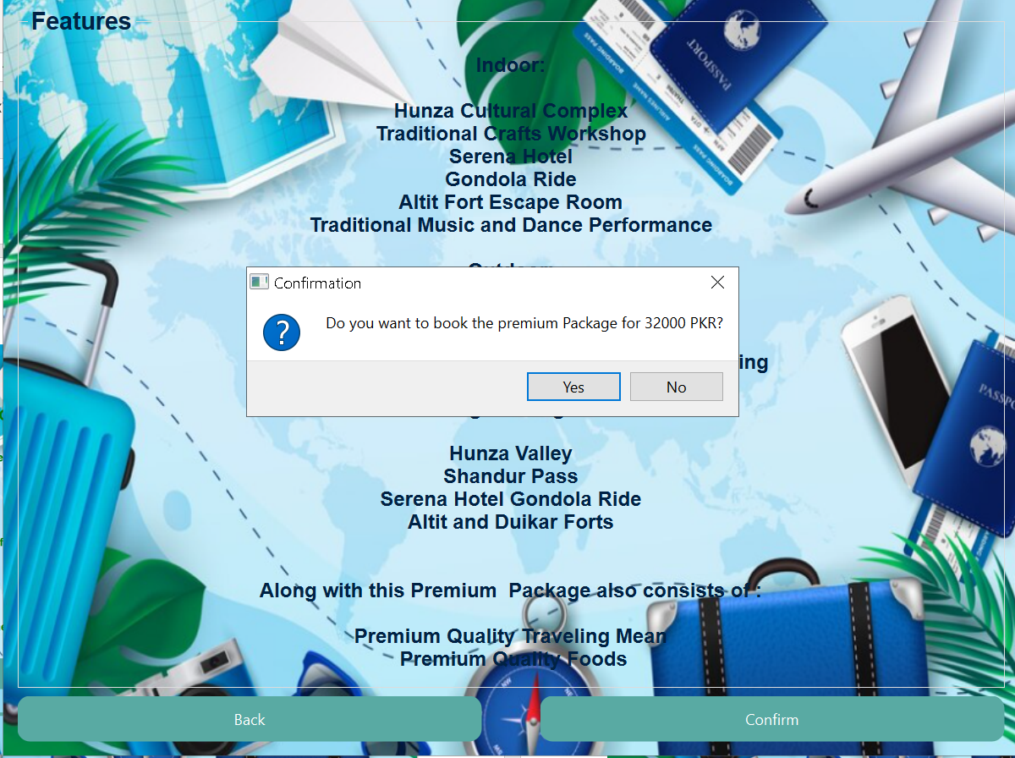

**If he books this a message is displayed confirming the booking.**

**Normal Tour Package Selection Page:**

This page showcases the Normal Tour Package, inviting you to explore its well-balanced offerings. If you find yourself drawn to this harmonious blend of attractions and affordability, you can proceed with a confident click on the confirmation button. Upon your agreement, a reassuring message will announce that your Normal Tour is now reserved for your enjoyment. The page then smoothly transitions you to the billing stage, where you'll finalize the financial aspects of your booking. However, if you desire to revisit other options or reconsider your choice, a back button stands ready to guide you back to the overview of pre-planned tour packages.

**Source Code:**

**normal.h:**

#ifndef NORMAL_H

#define NORMAL_H

#include <QDialog>

#include<QMessageBox>

namespace Ui {

class normal;

}

class normal : public QDialog

{

Q_OBJECT

public:

explicit normal(QWidget *parent = nullptr);

~normal();

private slots:

void on_connormbtn_clicked();

void on_backnormbtn_clicked();

private:

Ui::normal *ui;

};

#endif // NORMAL_H

**normal.cpp:**

#include "normal.h"

#include "ui_normal.h"

#include "preplanned.h"

#include "userdata.h"

#include "bill.h"

normal::normal(QWidget *parent) :

QDialog(parent),

ui(new Ui::normal)

{

ui->setupUi(this);

}

normal::~normal()

{

delete ui;

}

void normal::on_connormbtn_clicked()

{

// Prompt the user for booking confirmation

int result = QMessageBox::question(this, "Confirmation", "Do you want to book the Normal Package for 20000 PKR?", QMessageBox::Yes | QMessageBox::No);

if (result == QMessageBox::Yes) { // If user confirms booking

// Set the cost of the Normal Package

quint32 tourPackageCost = 18000;

// Display confirmation message

QMessageBox::information(this, "Congratulations", "Your Normal Tour has been booked");

// Store booking details in global data structure

UserData::instance().setPackagetype("Pre-planned");

UserData::instance().setTourCost(tourPackageCost);

// Proceed to billing

// Hide current form

hide();

//Displays the next form

bill bil;

bil.setModal(true);

bil.exec();

} else { // If user does not confirm booking

// ... Perform any necessary actions for canceled booking (placeholder)

}

}

void normal::on_backnormbtn_clicked(){

//Hides the current form

hide();

//Display's the previous form

preplanned back;

back.setModal(true);

back.exec();

}

**Screenshots:**

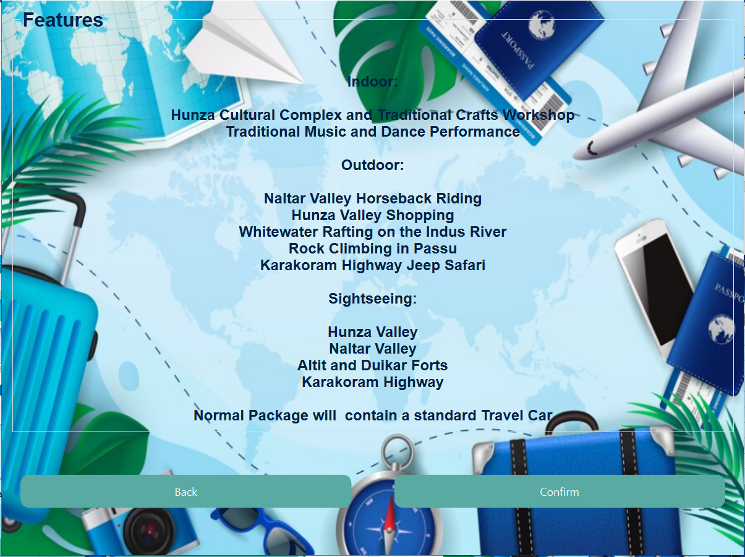

**User can book himself this package or can see between the other pages.**

**Economy Tour Package Selection Page:**

This pages whispers efficiency as it guides users through booking the budget-friendly Economy Package. A simple click on the confirmation button triggers a price check ( 10,000 PKR!), a celebratory message, and a secure entry in the grand ledger of bookings (the UserData structure). The page then smoothly transitions you to the billing stage, where you'll finalize the financial aspects of your booking. However, if you desire to revisit other options or reconsider your choice, a back button stands ready to guide you back to the overview of pre-planned tour packages.

**Source Code:**

**economy.h:**

#ifndef ECONOMY_H

#define ECONOMY_H

#include <QDialog>

#include<QMessageBox>

namespace Ui {

class economy;

}

class economy : public QDialog

{

Q_OBJECT

public:

explicit economy(QWidget *parent = nullptr);

~economy();

private slots:

void on_conecobtn_clicked();

void on_backecobtn_clicked();

private:

Ui::economy *ui;

};

#endif // ECONOMY_H

**economy.cpp:**

#include "economy.h"

#include "ui_economy.h"

#include"preplanned.h"

#include"userdata.h"

#include"bill.h"

economy::economy(QWidget *parent) :

QDialog(parent),

ui(new Ui::economy)

{

ui->setupUi(this);

}

economy::~economy()

{

delete ui;

}

void economy::on_conecobtn_clicked() {

// Prompt the user for booking confirmation

int result = QMessageBox::question( this, "Confirmation", "Do you want to book the Economy Package for 10000 PKR?",

QMessageBox::Yes | QMessageBox::No

);

if (result == QMessageBox::Yes) { // If user confirms booking

// ... Perform necessary booking actions

// Set the cost of the Economy Package

quint32 tourPackageCost = 10000;

// Inform the user of successful booking

QMessageBox::information(this, "Congratulations", "Your Economy Tour has been booked");

// Store booking details in global data structure

UserData::instance().setPackagetype("Pre-planned");

UserData::instance().setTourCost(tourPackageCost);

// Proceed to billing

// Hide current form

hide();

bill bil;

bil.setModal(true);

bil.exec();

} else { // If user does not confirm booking

// Do nothing (placeholder for any alternative actions)

}

}

void economy::on_backecobtn_clicked() {

// Hide current form

hide();

// Goes back to the previous form

preplanned back;

back.setModal(true);

back.exec();

}

**Screenshot:**

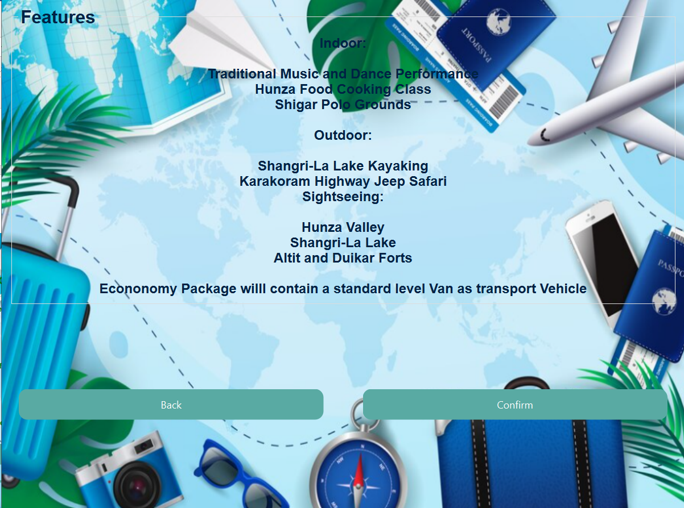

**User can book himself this package or can see between the other packages.**

**Custom Tour Package Selection Page - Indoor Activities:**

This page empowers you to design the perfect indoor experience for your trip. Choose from a tempting array of activities, each priced transparently for informed decision-making. As you tick the boxes, a watchful counter keeps track, ensuring you stay within the 5-activity limit for a balanced itinerary. Behind the scenes, a meticulous calculator tallies the total cost, keeping you informed every step of the way. A friendly warning pops up if you get a little too enthusiastic, gently guiding you back towards feasibility. Once your indoor adventure is perfectly crafted, a confident click propels you to the next stage, where outdoor pursuits await. The data on your chosen activities and their costs seamlessly flows along, weaving your personalized itinerary thread by thread. This page is a testament to the flexibility and user-friendliness at the heart of this booking system, allowing you to paint your ideal indoor experience with meticulous strokes.

**Source Code:**

**customindoor.h:**

#ifndef CUSTOMINDOOR_H

#define CUSTOMINDOOR_H

#include <QDialog>

#include<QMessageBox>

#include"customoutdoor.h"

namespace Ui {

class customindoor;

}

class customindoor : public QDialog

{

Q_OBJECT

public:

explicit customindoor(QWidget *parent = nullptr);

~customindoor();

private slots:

void on_nextbtn_clicked();

private:

Ui::customindoor *ui;

};

#endif // CUSTOMINDOOR_H

**customindoor.cpp:**

#include "customindoor.h"

#include "ui_customindoor.h"

#include"userdata.h"

customindoor::customindoor(QWidget *parent) :

QDialog(parent),

ui(new Ui::customindoor)

{

ui->setupUi(this);

}

customindoor::~customindoor()

{

delete ui;

}

void customindoor::on_nextbtn_clicked()

{

// Array to store individual activity costs

int activityCosts[7] = { 500, 750, 1200, 600, 2000, 2000, 100 };

// Counter to track the number of selected activities

int counter = 0;

// Variable to store the total cost of indoor activities

quint16 totalcostindoor = 0;

// Calculate individual activity cost based on selection

if (ui->checkBox->isChecked()) {

counter++;

totalcostindoor +=activityCosts[0];

}

if (ui->checkBox_2->isChecked()) {

counter++;

totalcostindoor +=activityCosts[1];

}

if (ui->checkBox_3->isChecked()) {

counter++;

totalcostindoor +=activityCosts[2];

}

if (ui->checkBox_4->isChecked()) {

counter++;

totalcostindoor +=activityCosts[3];

}

if (ui->checkBox_5->isChecked()) {

counter++;

totalcostindoor +=activityCosts[4];

}

if ( ui->checkBox_6->isChecked()) {

counter++;

totalcostindoor +=activityCosts[5];

}

if ( ui->checkBox_7->isChecked()) {

counter++;

totalcostindoor +=activityCosts[6];

}

//Checks and ensures that user selects maximum 5 activities

if (counter > 5) {

QMessageBox::warning(this, "Sorry", "You can only select up to 5 options");

} else {

// Set package type to "Custom"

UserData::instance().setPackagetype("Custom");

// Store the calculated total cost of indoor activities

UserData::instance().setIndoorCost(totalcostindoor);

// Proceed to outdoor activity selection

//hides this form

hide();

//opens the new form

customoutdoor co;

co.setModal(true);

co.exec();

}

}

**Screenshot:**

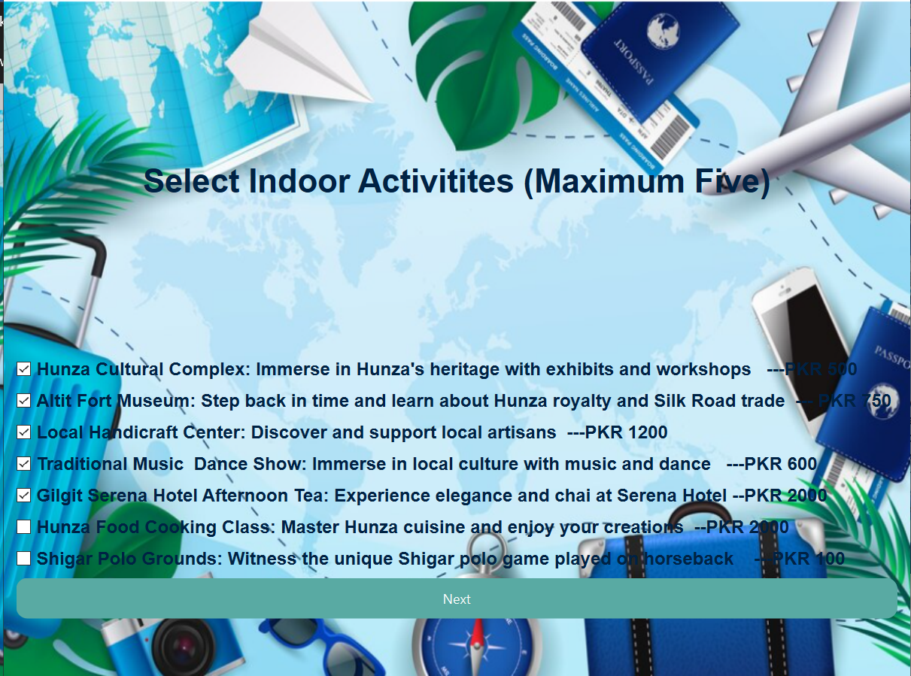

**If user selects the custom package then he select custom indoor activities User can select maximum five. If he selects more then five an error message is shown.**

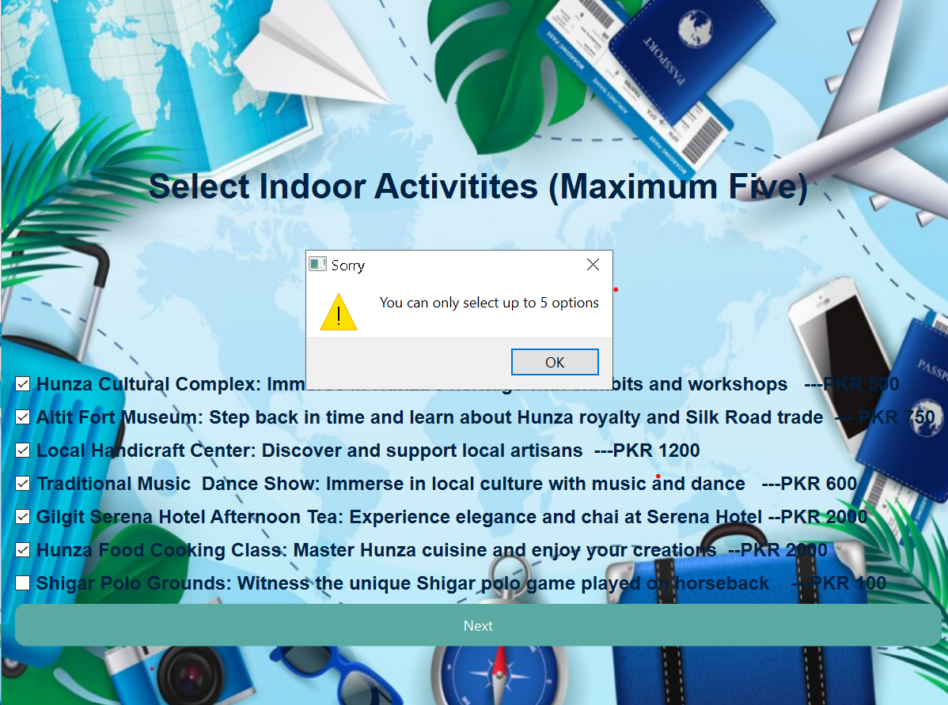

**This type of error is shown on selecting more then five activities.**

**Custom Tour Package Selection Page - Outdoor Activities:**

This page orchestrates the selection of outdoor activities within the custom tour package creation process. It presents users with a diverse range of outdoor pursuits, each accompanied by a transparent price, promoting informed decision-making. To ensure a balanced itinerary, a thoughtful counter guides users to select a maximum of 5 activities, preventing over-packing. The code diligently calculates the total cost of chosen activities in real-time, fostering financial awareness. Upon confirmation, it seamlessly transitions to the sightseeing activity selection stage, carefully storing the calculated outdoor cost for subsequent billing. This module exemplifies the system's dedication to crafting personalized experiences while maintaining cost transparency and user-friendly navigation.

**Source Code:**

**customoutdoor.h:**

#ifndef CUSTOMOUTDOOR_H

#define CUSTOMOUTDOOR_H

#include <QDialog>

#include<QMessageBox>

#include"customsightseeing.h"

namespace Ui {

class customoutdoor;

}

class customoutdoor : public QDialog

{

Q_OBJECT

public:

explicit customoutdoor(QWidget *parent = nullptr);

~customoutdoor();

private slots:

void on_nextbtn_clicked();

private:

Ui::customoutdoor *ui;

};

#endif // CUSTOMOUTDOOR_H

**customoutdoor.cpp:**

#include "customoutdoor.h"

#include "ui_customoutdoor.h"

#include"userdata.h"

customoutdoor::customoutdoor(QWidget *parent) :

QDialog(parent),

ui(new Ui::customoutdoor)

{

ui->setupUi(this);

}

customoutdoor::~customoutdoor()

{

delete ui;

}

void customoutdoor::on_nextbtn_clicked()

{

// Array to store activity costs

int activityCosts[7] = { 4500, 500, 5000, 6000, 1500, 2000, 1000 };

// Counter to track the number of selected activities

int counter = 0;

// Variable to store the total cost of indoor activities

quint16 totalcostoutdoor = 0;

// Calculate individual activity cost based on selection

if (ui->checkBox->isChecked()) {

counter++;

totalcostoutdoor +=activityCosts[0];

}

if (ui->checkBox_2->isChecked()) {

counter++;

totalcostoutdoor +=activityCosts[1];

}

if (ui->checkBox_3->isChecked()) {

counter++;

totalcostoutdoor +=activityCosts[2];

}

if (ui->checkBox_4->isChecked()) {

counter++;

totalcostoutdoor +=activityCosts[3];

}

if (ui->checkBox_5->isChecked()) {

counter++;

totalcostoutdoor +=activityCosts[4];

}

if ( ui->checkBox_6->isChecked()) {

counter++;

totalcostoutdoor +=activityCosts[5];

}

if ( ui->checkBox_7->isChecked()) {

counter++;

totalcostoutdoor +=activityCosts[6];

}

// Check if the user has selected more than 5 activities

if (counter > 5) {

QMessageBox::warning(this, "Sorry", "You can only select up to 5 options");

} else {

// Store the calculated total cost of indoor activities

UserData::instance().setOutdoorCost(totalcostoutdoor);

// Hide the current window

hide();

// Show custom sightseeing form

customsightseeing ss;

ss.setModal(true);

ss.exec();

}

}

**Screenshot:**

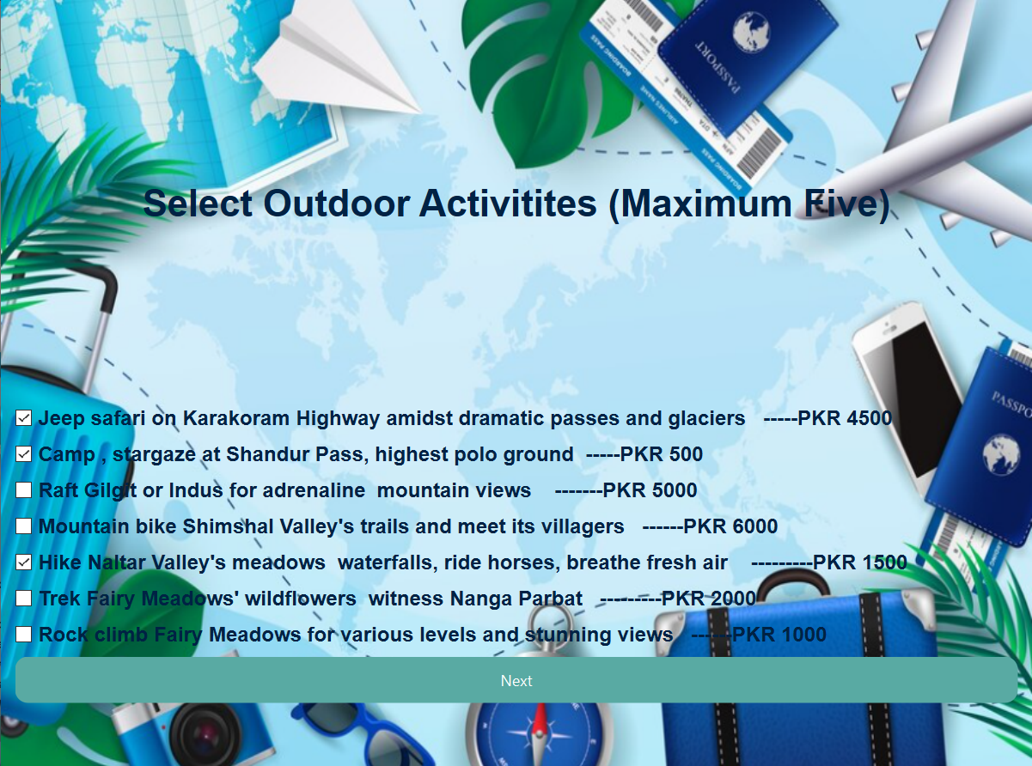

**After selecting custom indoor activities, user can select custom outdoor activities User can select maximum five. If he selects more then five an error message is shown.**

**Custom Tour Package Selection Page - Sightseeing Activities:**

This page empowers users to personalize their tour packages by selecting outdoor sightseeing activities that align with their interests. It presents a diverse array of activities, each with a transparent price, fostering informed decision-making. Users can select up to 5 activities to ensure a balanced itinerary, guided by a counter that prevents over-selection. The code meticulously calculates the total cost of chosen activities in real-time, keeping users aware of financial implications. Once selections are finalized, the code seamlessly transitions to the billing stage, storing the calculated cost for review and payment. This module highlights the system's commitment to flexibility, cost transparency, and user-centric design, fostering a positive booking experience.

**Source Code:**

**customsighteeing.h:**

#ifndef CUSTOMSIGHTSEEING_H

#define CUSTOMSIGHTSEEING_H

#include <QDialog>

#include<QMessageBox>

namespace Ui {

class customsightseeing;

}

class customsightseeing : public QDialog

{

Q_OBJECT

public:

explicit customsightseeing(QWidget *parent = nullptr);

~customsightseeing();

private slots:

void on_nextbtn_clicked();

private:

Ui::customsightseeing *ui;

};

#endif // CUSTOMSIGHTSEEING_H

**customsighteeing.cpp:**

#include "customsightseeing.h"

#include "ui_customsightseeing.h"

#include"bill.h"

#include"userdata.h"

customsightseeing::customsightseeing(QWidget *parent) :

QDialog(parent),

ui(new Ui::customsightseeing)

{

ui->setupUi(this);

}

customsightseeing::~customsightseeing()

{

delete ui;

}

void customsightseeing::on_nextbtn_clicked()

{

// Array to store activity costs

int activityCosts[7] = { 7500, 100, 900, 5000, 15000, 750, 5000 };

// Counter to track the number of selected activities

int counter = 0;

// Variable to store the total cost of indoor activities

quint16 totalcostsightseeing = 0;

// Calculate individual activity cost based on selection

if (ui->checkBox->isChecked()) {

counter++;

totalcostsightseeing +=activityCosts[0];

}

if (ui->checkBox_2->isChecked()) {

counter++;

totalcostsightseeing +=activityCosts[1];

}

if (ui->checkBox_3->isChecked()) {

counter++;

totalcostsightseeing +=activityCosts[2];

}

if (ui->checkBox_4->isChecked()) {

counter++;

totalcostsightseeing +=activityCosts[3];

}

if (ui->checkBox_5->isChecked()) {

counter++;

totalcostsightseeing +=activityCosts[4];

}

if ( ui->checkBox_6->isChecked()) {

counter++;

totalcostsightseeing +=activityCosts[5];

}

if ( ui->checkBox_7->isChecked()) {

counter++;

totalcostsightseeing +=activityCosts[6];

}

// Check if the user has selected more than 5 activities

if (counter > 5) {

QMessageBox::warning(this, "Sorry", "You can only select up to 5 options");

} else {

// Store the calculated total cost of indoor activities

UserData::instance().setSightseeingCost(totalcostsightseeing);

//hides this form

hide();

//shows the next from

bill bil;

bil.setModal(true);

bil.exec();

}

}

**Screenshot:**

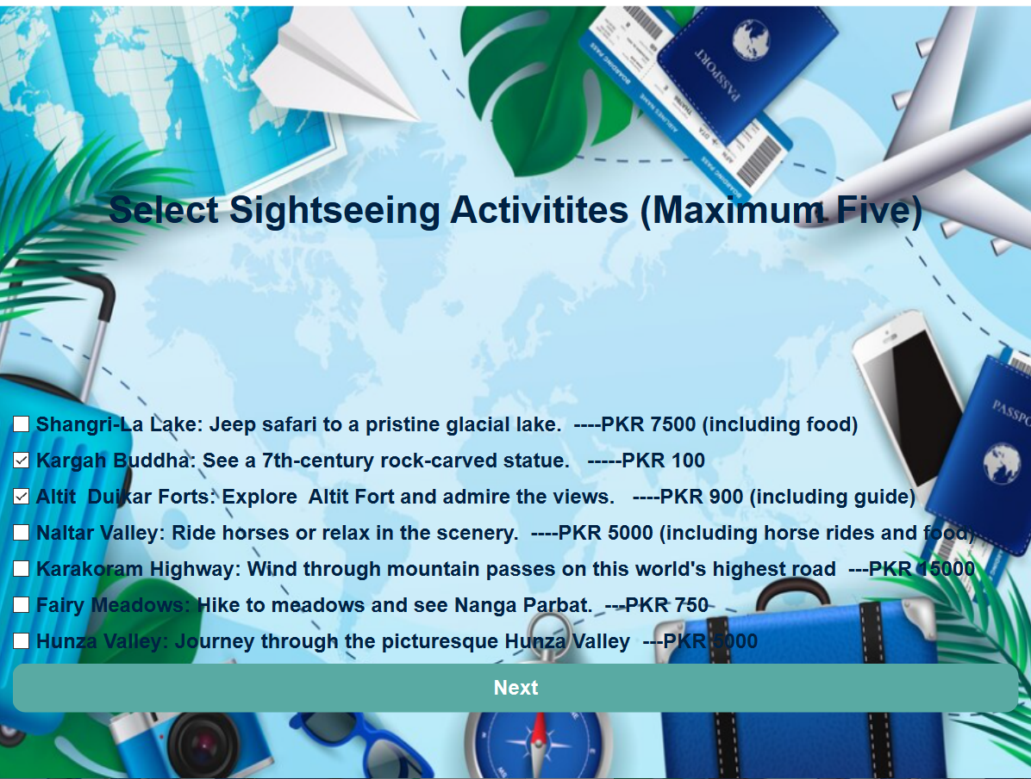

**After selecting custom outdoor activities, user can select custom sight seeing activities User can select maximum five. If he selects more then five an error message is shown.**

**Bill Page:**

This page serves as the grand finale of the booking experience, providing a transparent and user-friendly billing interface. It meticulously retrieves user data and cost information from the global UserData instance, ensuring accuracy and consistency. It gracefully handles both pre-planned and custom-designed tour packages, tailoring the displayed bill accordingly. For custom packages, it diligently calculates the total tour cost by aggregating individual activity costs, demonstrating attention to detail. The bill presents the user's name, hotel cost, tour cost, and total cost in a clear and concise format, promoting financial transparency. Upon payment confirmation, it celebrates the successful transaction with a congratulatory message and gracefully terminates the application, providing a smooth and satisfying conclusion to the booking journey.

**Source Code:**

**bill.h:**

#include "customsightseeing.h"

#include "ui_customsightseeing.h"

#include"bill.h"

#include"userdata.h"

customsightseeing::customsightseeing(QWidget *parent) :

QDialog(parent),

ui(new Ui::customsightseeing)

{

ui->setupUi(this);

}

customsightseeing::~customsightseeing()

{

delete ui;

}

void customsightseeing::on_nextbtn_clicked()

{

// Array to store activity costs

int activityCosts[7] = { 7500, 100, 900, 5000, 15000, 750, 5000 };

// Counter to track the number of selected activities

int counter = 0;

// Variable to store the total cost of indoor activities

quint16 totalcostsightseeing = 0;

// Calculate individual activity cost based on selection

if (ui->checkBox->isChecked()) {

counter++;

totalcostsightseeing +=activityCosts[0];

}

if (ui->checkBox_2->isChecked()) {

counter++;

totalcostsightseeing +=activityCosts[1];

}

if (ui->checkBox_3->isChecked()) {

counter++;

totalcostsightseeing +=activityCosts[2];

}

if (ui->checkBox_4->isChecked()) {

counter++;

totalcostsightseeing +=activityCosts[3];

}

if (ui->checkBox_5->isChecked()) {

counter++;

totalcostsightseeing +=activityCosts[4];

}

if ( ui->checkBox_6->isChecked()) {

counter++;

totalcostsightseeing +=activityCosts[5];

}

if ( ui->checkBox_7->isChecked()) {

counter++;

totalcostsightseeing +=activityCosts[6];

}

// Check if the user has selected more than 5 activities

if (counter > 5) {

QMessageBox::warning(this, "Sorry", "You can only select up to 5 options");

} else {

// Store the calculated total cost of indoor activities

UserData::instance().setSightseeingCost(totalcostsightseeing);

//hides this form

hide();

//shows the next from

bill bil;

bil.setModal(true);

bil.exec();

}

}

**bill.cpp:**

#include "bill.h"

#include "ui_bill.h"

#include "userdata.h"

#include<QMessageBox>

#include<QApplication>

bill::bill(QWidget *parent) :

QDialog(parent),

ui(new Ui::bill)

{

ui->setupUi(this);

displayBill(); // Call immediately to display bill on opening

}

bill::~bill() {

delete ui;

}

void bill::displayBill() {

//Store currency string as a variable to show it with amount

QString currency = "Pkr";

// Retrieve user data from the global UserData instance

QString name = UserData::instance().name();

int hotelCost = UserData::instance().hotelCost();

int tourCost = UserData::instance().tourCost();

QString packagetype = UserData::instance().packagetype();

// Display's billing information based on package type

if (packagetype == "Pre-planned") {

// Set text for name, hotel cost, and tour cost

ui->line1->setText(name);

ui->line2->setText(currency + " " +QString::number(hotelCost));

ui->line3->setText(currency + " " +QString::number(tourCost));

// Calculate and display total cost

int totalCost = hotelCost + tourCost;

ui->line4->setText(currency + " " +QString::number(totalCost));

}

else {

// Retrieve individual activity costs

int indoor = UserData::instance().indoorCost();

int outdoor = UserData::instance().outdoorCost();

int sightseeing = UserData::instance().sightseeingCost();

// Calculate total tour cost

int tourtotal = indoor + outdoor + sightseeing;

// Set text for name, hotel cost, and calculated tour cost

ui->line1->setText(name);

ui->line2->setText(currency + " " +QString::number(hotelCost));

ui->line3->setText(currency + " " +QString::number(tourtotal));

// Calculate and display total cost

int totalCost = hotelCost + tourtotal;

ui->line4->setText(currency + " " +QString::number(totalCost));

}

}

void bill::on_pushButton_clicked()

{

QMessageBox::information(this,"Congratulatons","Your Bill has been payed");

// Exit the application

QApplication::quit();

}

**Screenshot:**

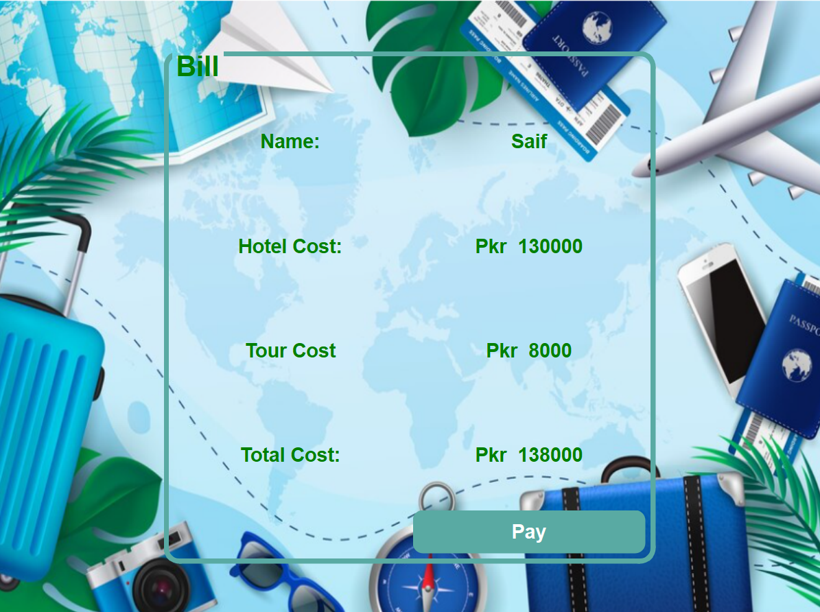

**This ui page will display the bill.**

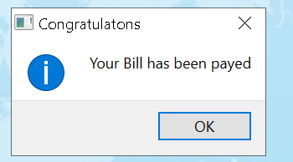

**UserData – Header File to store Data:**

This code establishes a robust and accessible data repository for managing user information and booking details throughout the application. It employs the Singleton design pattern, ensuring a single, consistent instance of the UserData class, promoting data integrity and avoiding conflicts. The class acts as a central hub, storing various booking details, including the user's name, hotel cost, tour cost, package type, and individual activity costs for custom packages. Its getter and setter methods enable seamless data access and modification across different code modules, fostering efficient communication and collaboration within the system. This class underscores the system's commitment to data organization and accessibility, contributing to a smooth and cohesive booking experience.

**Source Code:**

**userdata.h:**

#ifndef USERDATA_H

#define USERDATA_H

#include <QSettings>

class UserData {

public:

// Singleton pattern to ensure a single instance of UserData

static UserData& instance() {

static UserData instance;

return instance;

}

QString name() const { return _name; }

void setName(const QString& name) { _name = name; }

int hotelCost() const { return _hotelCost; }

void setHotelCost(int hotelCost) { _hotelCost = hotelCost; }

int tourCost() const { return _tourCost; }

void setTourCost(int tourCost) { _tourCost = tourCost; }

QString packagetype() const { return _packagetype; }

void setPackagetype(const QString& packagetype) { _packagetype = packagetype; }

int indoorCost() const { return _indoorCost; }

void setIndoorCost(int indoorCost) { _indoorCost = indoorCost; }

int outdoorCost() const { return _outdoorCost; }

void setOutdoorCost(int outdoorCost) { _outdoorCost = outdoorCost; }

int sightseeingCost() const { return _sightseeingCost; }

void setSightseeingCost(int sightseeingCost) { _sightseeingCost = sightseeingCost; }

private:

// Private constructor for singleton pattern

UserData() {}

// Member variables to store user data

QString _name;

int _hotelCost = 0;

int _tourCost = 0;

QString _packagetype;

int _indoorCost = 0;

int _outdoorCost = 0;

int _sightseeingCost = 0;

};

#endif // USERDATA_H

**Project External Links:**

**Youtube:**

<https://www.youtube.com/watch?v=qf93BO9wX-M>